# **Name: Abdurrahman Qureshi**

# **Roll No: 210451**

Practical No: 4

**1) Write a program to check whether the number is Palindrome or not using function.**

**CODE:**

const isPalindrome = (str) => {

let strBool;

let strNum = str.toString();

let strLen = strNum.length;

for (let i = 0; i < Math.floor(strLen / 2); i++) {

strBool = strNum[i] === strNum[strLen - i - 1];

}

if (strBool) {

process.stdout.write("The number " + str + " is a palindrome.");

} else {

process.stdout.write("The number " + str + " is not a palindrome.");

}

};

isPalindrome(12321);

**OUTPUT:**

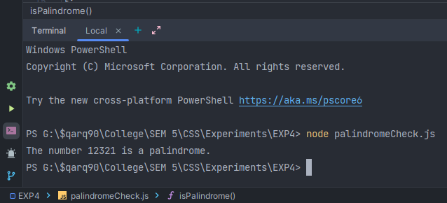

**2) Write a program to print the reverse of n digit number using function.**

**CODE:**

const isReverse = (num) => {

let myNum = num;

let rem = 0;

let rev = 0;

while (myNum > 0) {

rem = myNum % 10;

myNum = Number.parseInt(myNum / 10);

rev = rev * 10 + rem;

}

console.log("The reverse of " + num + " is " + rev);

};

isReverse(12345);

**OUTPUT:** 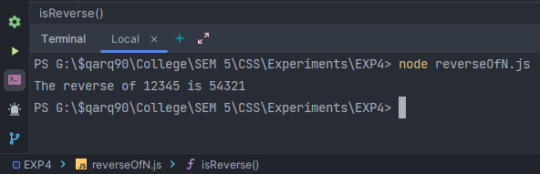

**3) Write a program to print the sum of n digit number using method.**

**CODE:**

const sumOfN = (num) => {

myNum = num;

let rem = 0;

let sum = 0;

while (myNum > 0) {

rem = myNum % 10;

myNum = Number.parseInt(myNum / 10);

sum = sum + rem;

}

console.log("Sum of " + num + " is : " + sum);

};

sumOfN(12345);

**OUTPUT:**

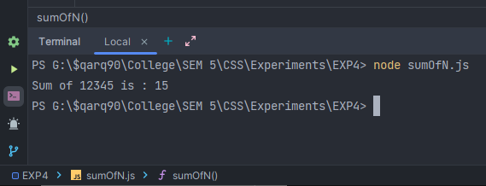

**4) Write a program to check whether number is an Armstrong or not using method.**

**CODE:**

const isArm = (num) => {

let n = num;

let rem = 0;

let arm = 0;

while (n > 0) {

rem = n % 10;

arm = arm + rem * rem * rem;

n = parseInt(n / 10);

}

if (arm == num) {

console.log("The number " + num + " is an armstrong number");

} else {

console.log("The number " + num + " is not an armstrong number");

}

};

isArm(10053);

**OUTPUT:**

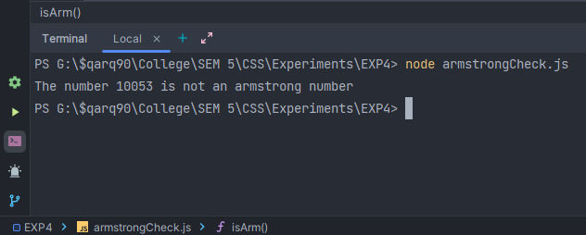 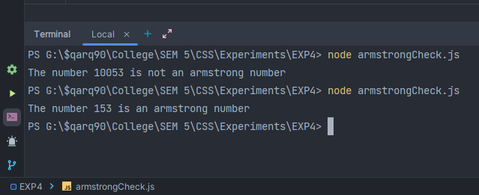

**5) Write a program to print the factorial series using constructor.**

**CODE:**

const factN = (num) => {

return num === 1 ? 1 : num * factN(num - 1);

};

function Factorial() {

this.factN = (myN) => {

console.log(`The factorial series of ${myN} is as follows:`);

for (let i = 1; i <= myN; i++) {

process.stdout.write(`${factN(i)} `);

}

};

}

const f = new Factorial();

f.factN(10);

**OUTPUT:**

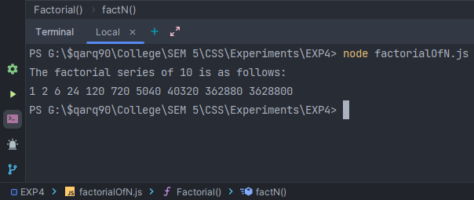

**6) Write a program to print the Fibonacci series using constructor.**

**CODE:**

const fiboN = (num) => {

if (num === 1) {

return 1;

} else {

return num * fiboN(num - 1);

}

};

function FibonacciSeries() {

this.fiboN = (myN) => {

let n1 = 0;

let n2 = 1;

console.log("The Fibonacci series of 10 is as follows:");

process.stdout.write(n1 + " " + n2 + " ");

for (let i = 1; i <= myN - 2; i++) {

let n3 = n1 + n2;

process.stdout.write(n3 + " ");

n1 = n2;

n2 = n3;

}

};

}

let f = new FibonacciSeries();

f.fiboN(10);

**OUTPUT:**

